Investing in Health Systems: Insights into How Health Financing Shapes Workforce Density, UHC Service Coverage Index, and Key Health Outcomes. A WHO African Regional Perspective.
Health financing refers to how resources are raised, pooled, and spent to fund health services. It determines who pays, how much, and for what. Some sources of health financing include government budgets (through taxation), compulsory and voluntary health insurance contributions, out-of-pocket payments by households, and external donor funding. Health financing in our context is measured by current health expenditure (CHE) per capita, composed of general domestic government health expenditure (GGHE-D), private domestic health expenditure (PVT-D), and external health expenditure (EXT). The domestic private health expenditure (PVT-D) is composed of the out-of-pocket expenditure (OOP) plus any voluntary health insurance and other private spending. To determine how health financing impacts workforce densities and key health outcomes such as life expectancy, maternal mortality, infant mortality, and universal service coverage, an analysis of data from the 47 WHO African regional countries spanning from 2000 to 2024 was conducted to ascertain the optimal proportions of CHE and workforce density cadres needed to optimize the key health outcomes and how different health investments impact on health workforce densities.
Optimization of Current Health Expenditure (Health Financing) Components using Key Health Outcomes and UHC Service Coverage Index
Health financing is central to achieving 100% Universal Health Service Coverage (UHC). WHO standards emphasize raising sufficient funds, pooling risks fairly, and purchasing services strategically to ensure people have access to quality care without financial hardship. Most countries in Africa face challenges such as high out-of-pocket (OOP) spending, fragmented risk pools, underfunding of public health, and overreliance on donor funding. In this section, we aim to identify the optimal proportions of government (GGHED), donor (EXT), and private (PVTD) expenditure required to maximize Universal Health Service Coverage (UHC), maximize life expectancy, minimize maternal mortality ratio (MMR), and minimize infant mortality ratio (IMR) because after all, “Health financing is not just about spending more, but spending better and pooling risks fairly”.
A correlation analysis between CHE and UHC_SCI and the key health outcomes was done, and the results were as recorded in Table 1.
Table 1: Correlation between CHE and Key Health Outcomes
 | UHC_SCI | LE | MMR | IMR
CHE | 0.72 | 0.31 | -0.45 | -0.46

Results from Table 1 show that there is a strong positive association between current health expenditure and universal health coverage, implying that higher investment in health is strongly associated with better service coverage. A weak positive correlation was also observed between health expenditure and life expectancy, indicating that higher spending is associated with longer life expectancy. In addition to this, increased health expenditure was found to be moderately associated with lower maternal and infant deaths. This implies that spending more on health improves access to health services, reduces mortality, and improves life expectancy.
A visual plot of how the four health outcomes (UHC_SCI, LE, MMR, and IMR) relate to CHE was created to show the type of relationship among them (see Figure 1).
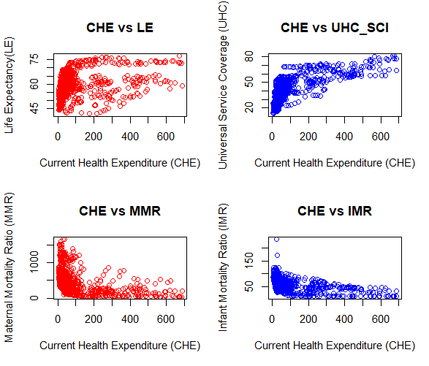
Figure 1: Relationship between CHE and Key Health Outcomes
Figure 1 shows that life expectancy (LE) and universal health coverage index (UHC_SCI) non-linearly increase with an increase in current health expenditure (CHE). Similarly, maternal mortality ratio (MMR) and infant mortality ratio (IMR) non-linearly decrease with an increase in current health expenditure. Due to the nonlinear relationship between CHE and the key health outcomes, it was assumed that all the CHE components (GGHED, EXT, and PVTD) are also nonlinearly correlated with LE, UHC_SCI, MMR, and IMR. A generalized additive regression model, see equation (1), was fitted to the data to capture the effect the different CHE components have on either LE, UHC_SCI, MMR or IMR.
g(E[KHO]) =$β_{0}+f_{1}$(EXT)+$f_{2}$(GGHED)+$f_{3}$(PVTD)+e (1)
where KHO is the key health outcome: LE, MMR, IMR, UHC_SCI, g(.) is a link function, $f_{j}(.)$ is a smooth function, e is the error term.

The results of the four fitted models are shown in Table 2.
Table 2: GAM Results on effect of CHE components on Specific Key Health Outcomes
Key Health Variable | EXT | GGHED | PVTD | Explained  Deviance(%)
Life Expectancy (LE) | 6.447*** | 7.975*** | 5.440*** | 30.2
Maternal Mortality Ratio (MMR) | 3.839*** | 8.692*** | 8.130*** | 40.3
Infant Mortality Rate (IMR) | 5.363*** | 8.565*** | 3.620*** | 42.2
Universal Health Coverage (UHC_SCI) | 7.769*** | 6.960*** | 6.617*** | 73.1
Sig. codes: ***<0.001, **<0.01, *<0.05

Table 2 results show that all CHE components significantly improve life expectancy (LE) and reduce maternal and infant mortality ratios, with government funding having the most powerful effect in all three health outcomes. PVTD was found to have the second strongest significant effect on reducing maternal deaths, whereas external donor funding had the second strongest significant effect on reducing infant deaths and increasing life expectancy. External donor funding (EXT) was found to be the most significant contributor towards improving service health coverage (UHC-SCI), followed by government funding (GGHED) and private funding (PVTD. These results show that government expenditure on health (GGHED) consistently has the most powerful effect on all three health outcomes: life expectancy, maternal mortality, and infant mortality. Private health spending (PVTD) plays a strong role in reducing maternal mortality and improving universal health service coverage, whereas external funding plays a strong role in reducing infant mortality and increasing life expectancy. This is why we went ahead to determine the optimal proportion of levels of CHE components that would achieve our objective function of minimizing maternal and infant deaths while maximizing life expectancy and service coverage:
$$\min_{j}{f_{j}(i)}$$
Such that;
$$\left\{\begin{aligned}{CHE}_{j}=ω_{1j}EXT+ω_{2j}GGHED+ω_{3j}PVTD \\ j=(-LE, MMR, IMR, -UHC_{SCI}) \\ i=\{EXT, GGHED, PVTD\}\end{aligned}\right.$$

Subject to the constraints
$ω_{ij}≥0$ and $\sum_{i}{ω_{ij}}=1$

The results of the GAM were fed into the nonlinear optimization model, and the proportions of CHE (%) to achieve optimal levels of each health outcome are shown in Table 3.
Table 3: CHE Components Allocations to achieve Optimal Health Outcomes (%)
Key Health Variable | EXT | GGHED | PVTD
Life Expectancy (LE) | 13.76 | 50.05 | 36.19
Maternal Mortality Ratio (MMR) | 7.71 | 92.29 | 0.00
Infant Mortality Rate (IMR) | 16.68 | 43.95 | 39.37
Universal Health Coverage (UHC_SCI) | 17.98 | 82.02 | 0.00
Averages | 14.03 | 67.08 | 18.89

Table 3 results show that to optimize health systems (as seen from the different health outcomes by maximizing life expectancy and universal service health coverage while minimizing infant mortality and maternal mortality ratios), governments funding (GGHED) needs to take up the giant share (67%) of current health expenditure, followed by private-level funding (PVTD) contributing around 19% of CHE, including out-of-pocket expenditure (OOP) and the smallest share (14% of CHE) should come from external funding sources (EXT) such as donors.
A descriptive analysis of the effect of governments' spending 67% or more of their CHEs on the four health outcomes was done, where an average was performed on the four health outcomes for countries spending 67% of GGHED on CHE compared to those that spend less, just to view whether there is any visible difference. A summary of the same is given in Table 4.
Table 4: Effect of Government Spending 67% or more of CHE on Health Outcomes
Government Expenditure (GGHED) | SCI_UHC | LE | MMR | IMR
Less than 67% of CHE | 39.3 | 59.3 | 496.0 | 58.0
67% or more of CHE | 65.3 | 71.8 | 81.5 | 24.0

Table 4 shows that governments investing in 67% or more of their current health expenditure (CHE) observe 26% higher universal service health coverage indices, 12.5 years higher life expectancy levels, 414.5 fewer maternal deaths per 100,000 live births, and 34 fewer deaths per 1,000 live births compared to those who spend less.
Analyzing the Optimal Health Workforce Density Benchmarks to achieve Key Health Outcomes and UHC Service Coverage Index before Diminishing Returns.
Health workforce density refers to the number of health care professionals, such as doctors, nurses, midwives, pharmacists, dentists, etc., available per unit of population. In this section, we assume that this number is measured per 10,000 population. Evidence from the World Health Organization (WHO) demonstrates that a minimum density of 44.5 doctors, nurses, and midwives per 10,000 population is essential to deliver essential health services and sustain progress toward UHC (World Health Organization, 2025). Countries that reach or surpass this threshold consistently record service coverage indices above 70%, reflecting improved access, quality, and equity in care (Ahmat, Asamani, & Illou, 2022). To understand whether equal distribution of health workers across cadres can suffice, the average observed proportion of health workers per 10,000 population for each cadre that met the 70% UHC, as per the historical dataset, was calculated and recorded in Table 5.
Table 5: Descriptive Analysis of the Minimum Achievement of 70 % UHC per 10,000 population
Cadre | Doctors | Dentists | Nursing_Midwifery | Pharmacists | Total
Average per 10,000 population | 11.09 | 2.19 | 28.53 | 2.81 | 44.61
Proportion per doctor | 1.000 | 0.197 | 2.573 | 0.254

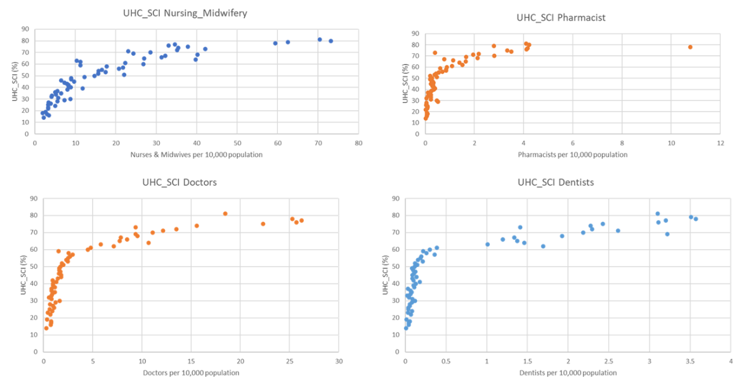
It was observed (see Table 5) that, on average, a minimum of about 11.09 doctors, 2.19 dentists, 28.53 nurses and midwives, and 2.81 pharmacists are required per 10,000 population to achieve at least 70% Universal Health Service Coverage levels. Implying that the journey to achieving 100% Universal Health Coverage (UHC) doesn’t require an equitable but rather a well-distributed health workforce across cadres. A non-linear relationship between UHC_SCI and the different HWF density cadres was spotted from the visual plot (See Figure 2).
Figure 2: Relationship between UHC and Cadre Specific HWF Densities
A similar non-linear relationship was assumed between health workforce densities of different cadres and the key health outcomes such as life expectancy (LE), maternal mortality ratio (MMR), and infant mortality ratio (IMR). A generalized additive model, see equation (2), was fitted to examine the relationship between a specific key health outcome and the workforce density of a specific cadre per 10,000 population to help us determine the threshold above which we record diminishing effects despite an increase in the health workforce workers from a specific cadre.
g(E[KHO])=$β_{0}+f_{1}$(Workforce_Cadre)+e (2)
where KHO is the key health outcome: LE, MMR, IMR, UHC_SCI, g(.) is a link function, $f_{j}(.)$ is a smooth function, Workforce_Cadre: Doctors, Nurses/Midwives, Dentists, Pharmacists, e is the error term. Table 6 gives a summary of the optimal allocation of doctors, nurses, midwives, dentists, and pharmacists per 10,000 population, where key health outcome variables are optimized.
 | Table 6: Optimal Health Workforce Density Thresholds per 10,000 population Required for Key Health Outcomes
Key Health Variable |  | Doctors | Nurses & Midwives | Dentists | Pharmacists | Total
Life Expectancy (LE) |  | 30.52 | 29.25 | 2.57 | 5.15 | 67.49
Maternal Mortality Ratio (MMR) |  | 11.96 | 60.91 | 2.17 | 10.08 | 85.12
Infant Mortality Rate (IMR) |  | 31.61 | 46.35 | 2.85 | 7.96 | 88.77
Universal Health Coverage (UHC_SCI) |  | 12.69 | 47.44 | 3.16 | 7.88 | 71.17
Averages |  | 21.70 | 45.99 | 2.69 | 7.77 | 78.15

Results from Table 6 demonstrate that key health outcomes such as life expectancy, maternal mortality, infant mortality, and service coverage improve sharply as workforce densities rise, but gains diminish above these thresholds. It was discovered that for life expectancy to significantly increase, we need 31 doctors, 30 nurses and midwives, 3 dentists, and 6 pharmacists per 10,000 population. Similarly, for service coverage to increase, we need 13 doctors, 48 nurses and midwives, 4 dentists, and 8 pharmacists per 10,000 population. On the other hand, for maternal deaths to rapidly reduce, we need 12 doctors, 61 nurses, 3 dentists, and 11 pharmacists. Similarly, for infant deaths to be reduced, we need 32 doctors, 47 nurses, 3 dentists, and 8 pharmacists. Therefore, on average across all health outcomes, we need around 22 to 32 doctors, 46 to 61 nurses, 3 to 4 dentists, and 8 to 11 pharmacists per 10,000 population, with significant improvements in mortality ratios requiring more health workers.

Analyzing the Optimal Government Health Financing Limits that boost Health Workforce Density .
In this section, we determine whether government financing on health (GGHED) has any effect on health workforce (HWF) densities and whether an increase in government expenditure has infinite or diminishing returns. A generalized additive model (GAM) was first fitted to the data to help us capture current or any delayed effects that government health expenditure has on health workforce density, where the current to the fifth GGHED lags were included in the model. The fitted GAM model was given by:
$${HWF}_{it}=α{+f(GGHED}_{it}){+f(GGHED}_{i(t-1)}){+f(GGHED}_{i(t-2)}){+f(GGHED}_{i(t-3)})$$
${+f(GGHED}_{i(t-4)}){+f(GGHED}_{i(t-5)})+e_{it}$ (3)
The fitted lagged GAM model was found to have an explained deviance of 85.3% and adjusted $R^{2}$ of 83.6% with an intercept of α=17.57***, and the smoothed parameter estimates were as summarized in Table 7:
Table 7: Lagged GAM Model Results on the effect of GGHED per capita on HWF
Variable | edf | Ref.df | F-value | pvalue
f(GGHED_Lag0) | 8.174 | 8.745 | 3.716 | 0.0002
f(GGHED_Lag1) | 1.000 | 1.000 | 0.156 | 0.6930
f(GGHED_Lag2) | 1.433 | 1.769 | 0.735 | 0.5703
f(GGHED_Lag3) | 1.000 | 1.000 | 2.746 | 0.0989
f(GGHED_Lag4) | 6.419 | 7.558 | 1.669 | 0.1299
f(GGHED_Lag5) | 8.203 | 8.762 | 4.383 | 0.0000

Table 7 results show that current and 5-year lagged government spending levels on health (GGHED) have a strong non-linear (both edfs>>1), significant effect on health workforce density. However, the strongest non-linear effect is observed after 5 years, suggesting that health financing has a delayed effect, which translates into workforce growth through other constraints such as training, retention, and so on. Implying that government health expenditure per capita influences health workforce density both immediately (maybe through hiring, retention, or salary adjustments) and through delayed long-term effects (maybe through training and deployment of health workers).
The non-linear effect of the current and 5-year lagged GGHED levels on workforce densities implied that there might be different thresholds depicting a possibility of diminishing returns. This is why a lagged GAM threshold model was fitted to the data to determine whether indeed there are any thresholds in the data where the derivatives of the smoothed estimates change signs, showing the direction where expenditure changes highlight phases of growth and decline in health workforce densities. The current and 5-year lagged government health expenditure threshold effects on health workforce were extracted from the fitted lagged GAM threshold model, and the results were summarized in Tables 8 and 9 as visualized in Figures 3 and 4.
Table 8 : GGHED Threshold on HWF
GGHED per capita, $ | Derivative
29 | 0.0211
87 | -0.0144
162 | 0.0106
337 | -0.0226
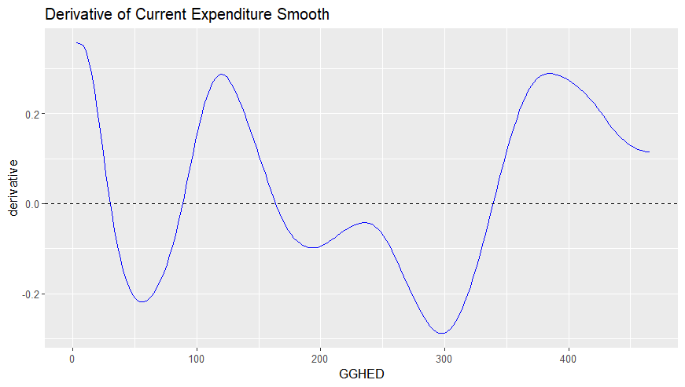
Figure 3: Current GGHED Threshold Effects on HWF
Table 8 show that for current levels of government financing on health, thresholds occur at 29, 87, 162, and 337 dollars per capita, showing alternating phases of growth and decline as spending increases (See Figure 3).
Table 9 : Five-Year Lagged GGHED Threshold on HWF
GGHED per capita, $ | Derivative
81 | 0.0117
129 | -0.0005
174 | 0.0066
214 | -0.0167
300 | 0.0107
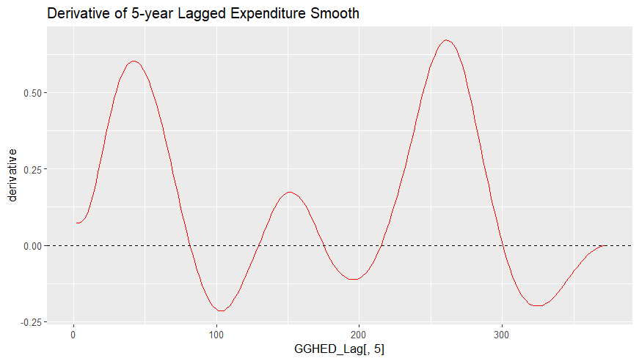
Figure 4: Five-Year Lagged GGHED Threshold Effects on HWF
Similarly, Table 9 show that for 5-year lagged levels of government financing on health, thresholds occur at 81, 129,174, 214 and 300 dollars per capita, showing alternating phases of growth and decline as spending increases (See Figure 4). Both the current and 5-year lag threshold models showed there are levels of government expenditure (GGHED) on health where the derivatives of the smooth function f(.) changes sign. Periods with positive derivatives imply that increased expenditure at those levels lead to increased workforce growth whereas periods with negative derivatives imply that at these levels, increased expenditure yields diminishing or negative returns on health workforce densities, implying that more health spending doesn’t guarantee more workforce as efficiency and allocation also matter.
Finally, using the GAM results, we computed the health workforce density elasticity with respect to the government expenditure (GGHED) at different levels. This was done to allow us to measure the percentage change in health workforce density for a percentage increase in GGHED. The elasticity function was given by:
$$Elasticity=\frac{∂HWF}{∂GGHED}*\frac{GGHED}{HWF}$$
Figure 5 shows the effect of government expenditure on health workforce density and the resulting elasticity levels for different levels of government health financing. 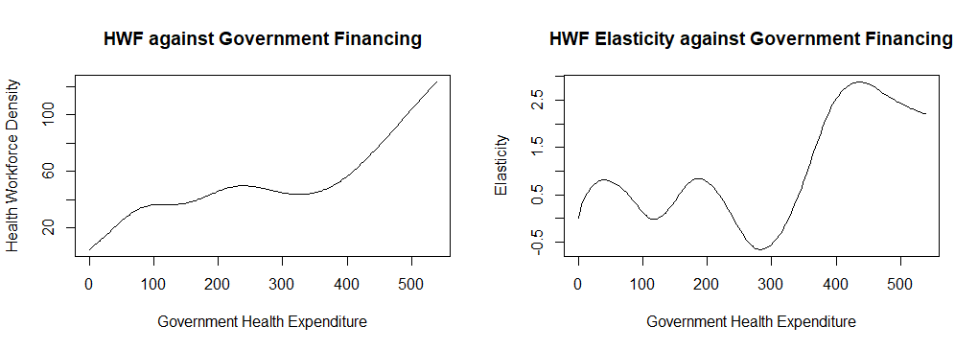
a) GGHED vs Health Workforce Density b) GGHED vs HWF Elasticity
Figure 5: Effect of Government Financing on Health Workforce Density and Elasticity
Figure 5a) shows that health workforce density increases with an increase in government expenditure, although not linearly. Figure 5b) shows that health workforce elasticity levels increase and decrease at different levels of GGHED, with local optimum GGHED levels per capita recorded at $40.75, $186.83, and $438.41, responding to a local optimum total of 21.12, 43.46, and 72.88 doctors, nurses, midwives, pharmacists, and dentists collectively per 10,000 population, respectively.
From our results in the first section, we found that to collectively achieve optimal health outcomes, such as increased life expectancy, improved health coverage, and reduced maternal and infant mortality ratios, we need an average of 78.16 doctors, nurses, midwives, pharmacists, and dentists collectively. This results in a GGHED of $449.23 per capita. Hence, governments that plough in an amount of $449.23 per capita towards their current health expenditure are set to see optimal health outcomes. However, for governments that are unable to reach these GGHED levels can work hard towards achieving the local optimum levels, either at $40.75 per capita, or $186.83 per capita, or $438.41 per capita.
References
- Ahmat, A., Asamani, J. A., Illou, M. M. A., Millogo, J. J. S., Okoroafor, S. C., Nabyonga-Orem, J., ... & Nyoni, J. (2022). Estimating the threshold of health workforce densities towards universal health coverage in Africa. BMJ Global Health, 7(Suppl 1), e008310.
- World Health Organization. (2025). World health statistics 2025: monitoring health for the SDGs, Sustainable Development Goals. World Health Organization.

Investing in Health Systems Dashboard
